

DOMAIN : ROBOTICS & AUTOMATION

TITLE OF REPORT : MINI PROJECT ON ROLE OF AI IN AUTONOMOUS ROBOTS

NAME : DARSHANI SADASHIV MADGUNDI.

QUALIFICATION : B. TECH 2nd YEAR IN MECHANICAL ENGINEERING

COLLEGE : N.B. NAVALE SINHGAD COLLEGE OF ENGINEERING KEGAON, SOLAPUR .

CONTENTS :

Sr. No. | TITLE | Page No.
1 | Introduction | 1
2 | Contents | 2
3 | Introduction In Detailed | 3
4 | Architectural Framework: The Perception Planning-Action Loop | 4
5 | Core AI Technologies Driving Modern Robotics | 6
6 | Key Cross-Industry Applications | 7
7 | Major Technical Challenges and Bottlenecks | 8
8 | Conclusion & Future Outlook | 9
9 | References | 10

1. Introduction In Detailed

1.1 Background
For decades, traditional robotics functioned primarily as a byproduct of deterministic programming. Mechanical arms and automated guided vehicles (AGVs) operated within rigidly controlled, fenced environments, repeating precise, hard-coded scripts. While highly efficient for high-volume, static tasks, these machines were fundamentally "blind" and "mindless"—unable to adapt to the slightest variation in their environment. Any unexpected obstacle, shifted part, or human presence typically resulted in a system error or an immediate safety shutdown.

1.2 The Paradigm Shift to Autonomy
The integration of Artificial Intelligence (AI) marks the transition from pre-programmed automation to true robotic autonomy. By imbuing physical machinery with cognitive capabilities, AI serves as the digital "brain," while the robotic chassis acts as the "body." As of 2026, this convergence has given rise to Embodied AI—systems capable of perceiving their environments, reasoning through complex scenarios, learning from physical interaction, and executing multi-step tasks independently.
According to data from the International Federation of Robotics (IFR), the integration of Analytical and Generative AI into industrial and logistics fleets is the defining driver of the robotics market, which is projected to grow exponentially through the late 2020s.
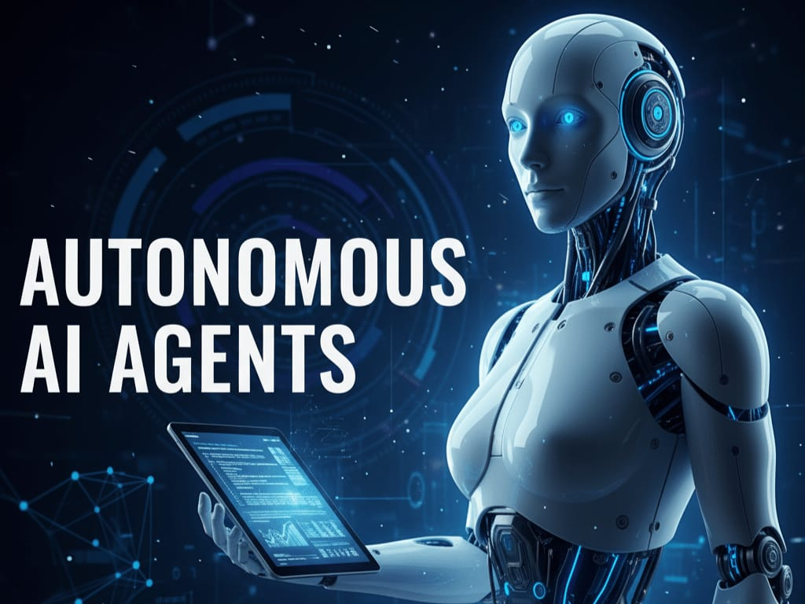

2. Architectural Framework: The Perception-Planning-Action Loop
AI transforms a robot's operational loop from a linear script into a continuous, real-time feedback system known as the Perception-Planning-Action Loop.
Medium
+-----------------------------------------------+
| | v |
[ SENSING ] (Raw Data: LiDAR, Cameras, Radar) |
| | v |
[ PERCEPTION ] (AI Sensor Fusion & Object Class) | (Continuous Feedback)
| | v |
[ PLANNING ] (AI Policy Networks & Reasoning) |
| | v |
[ ACTION ] (Actuators, Motors, Kinetic Output) |
| |
+-----------------------------------------------+

2.1 Perception (Sensing and Data Interpretation)
Raw physical data captured by LiDAR, ultrasonic sensors, and 3D cameras is meaningless without contextual interpretation. AI algorithms perform Sensor Fusion, cross-referencing disparate data streams simultaneously to construct a rich, semantic 3D understanding of the surrounding space. Through Computer Vision, the robot doesn't just register a shape; it identifies it specifically as a human worker, a structural column, or a piece of debris.
ResearchGate

2.2 Planning (Cognitive Decision-Making)
Once the environment is mapped, AI handles the cognitive load of path planning, risk assessment, and task delegation. Instead of following static coordinate paths, the AI evaluates multiple operational paths, calculates the probability of dynamic obstacles moving (such as predicting a pedestrian's walking trajectory), and selects the most efficient, collision-free route.
ResearchGate

2.3 Action (Kinetic Execution and Control)
The plan is translated into precise electrical signals sent to motors, joints, and actuators. What makes this phase AI-driven is Real-Time Error Correction. If a robotic gripper detects a slight slip while picking up an object, the AI mid-action modifies the force feedback loop to stabilize the asset without dropping it or crushing it.
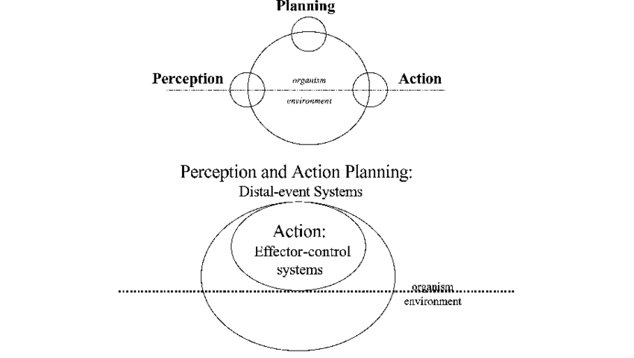

3. Core AI Technologies Driving Modern Robotics
The modern autonomous robot relies on a cross-disciplinary suite of AI subfields, each managing distinct components of its cognitive stack.

3.1 Computer Vision & Scene Segmentation
Advanced deep neural networks allow robots to execute pixel-level semantic segmentation. This enables a robot to distinguish between passable terrain and hazardous drops, read safety signage, and identify microscopic structural defects on an assembly line in real time.

3.2 Reinforcement Learning (RL) and Deep RL
Instead of manually programming how a robot should balance on uneven terrain or grasp a uniquely shaped object, engineers use Reinforcement Learning. Robots train in physics-based virtual simulations, running millions of iterations of trial and error to learn optimal control policies. These learned behaviors are then deployed directly onto physical hardware (Sim-toReal transfer).

3.3 Generative AI and Foundation Models
A massive breakthrough leading into 2026 is the deployment of Vision-Language-Action (VLA) models. Generative AI has shifted robotics away from rigid automation toward intelligent, self-evolving systems. Rather than requiring code updates to learn a new task, robots equipped with VLA models can understand natural language instructions (e.g., "Find the damaged box on the bottom shelf and place it in the disposal bin") and map those abstract instructions directly to physical actions.

3.4 Hybrid Agentic AI
The newest architectural trend pairs Analytical AI (used for strict mathematical optimization, predictive maintenance, and precise path calculations) with Generative AI (used for high-level reasoning and environmental adaptability). This hybrid model allows robots to function entirely independently in unpredictable, real-world settings.

4. Key Cross-Industry Applications
 | Industry Segment | Specific AI Robotics Use-Case | Core Operational Impact
 | Logistics &  Supply Chain | Autonomous Mobile Robots  (AMRs) (e.g., Boston Dynamics  Stretch, Amazon logistics fleets). | Dynamically navigate unmapped warehouses, autonomously sort packages, and optimize last-mile sorting.
 | Manufacturing | Collaborative Robots (Cobots) and Industrial Humanoids. | Work safely fence-free alongside human operators, instantly adapting to human speed and positional changes.
 | Healthcare | AI-Assisted Surgical Robotics and autonomous bio-hazard delivery units. | Filters out physiological tremors during micro-surgeries; automates sterile tracking and hazardous waste disposal.
 | Agriculture | Smart Ag-Bots (Autonomous tractors, weed-picking drones). | Uses vision-based AI to scan crops, applying micro-doses of pesticide directly to weeds while bypassing crops.
 |  |  | 7

5. Major Technical Challenges and Bottlenecks
Despite significant technological leaps, scaling fully autonomous AI robots faces strict computational and engineering hurdles:

5.1 Edge Computing vs. Latency
An autonomous system cannot rely on cloud-based AI processing when making split-second safety decisions; a network lag of even 50 milliseconds could result in an accident. Robots must process multi-modal neural networks locally on the machine. This has forced massive industry investments into specialized hardware, such as edge-tailored computing modules (e.g., NVIDIA's Jetson architectures) capable of executing heavy AI workloads with minimal power draw.

5.2 Unpredictable Edge Cases
AI models are trained on historical data. When a robot encounters an "edge case"—a completely novel scenario missing from its training data, such as a rare weather anomaly or bizarre human behavior—the model's predictive certainty drops. Engineering robust fallback and safe-fail protocols for these edge cases remains a primary bottleneck to full Level-5 autonomy.

5.3 The Explainability & Safety Audit Gap
Deep neural networks operate as "black boxes," making it mathematically challenging to deduce why an AI model made a specific errant decision. In highly regulated sectors like automotive manufacturing and invasive healthcare, this lack of step-by-step explainability creates severe insurance, liability, and regulatory compliance hurdles.

6. Conclusion & Future Outlook
The role of artificial intelligence in autonomous robotics has fundamentally shifted from an optional feature upgrade to the very foundation of modern physical automation. By transforming robots from rigid execution tools into perceptive, learning entities, AI is actively solving critical global macroeconomic challenges, including severe labor shortages and supply chain vulnerabilities.
Over the next five to ten years, the commercial focus will center heavily on expanding
Embodied Physical AI. As hybrid Agentic AI systems mature and edge processors become more powerful, autonomous robots will increasingly leave structured industrial environments to seamlessly blend into dynamic, unpredictable human spaces as safe, productive, and highly versatile collaborators.

7. References
https://robotnik.eu/artificial-intelligence-and-robotics/

https://mkce.ac.in/blog/autonomous-systems-powered-by-artificial-intelligence-andmachine-learning/

